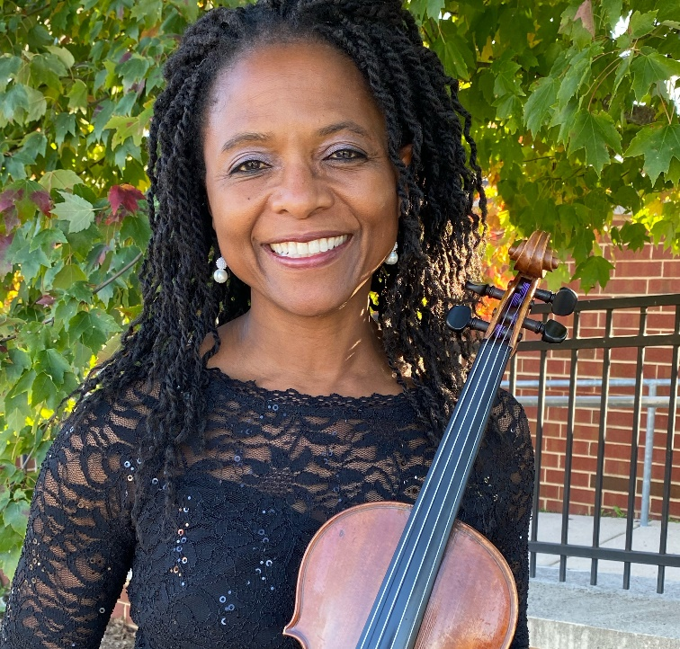
Veronica Jackson -
Educator, Conductor,
Violinist
After graduating from W. G. Enloe - Magnet High School (Raleigh, North Carolina) in 1985, Ms. Jackson studied violin at the University of Miami (Coral Gables) with Dr. Marla Meutschler (Paul Rolland protégé) and Dr. Earl Sanders at North Carolina Central University (NCCU). Graduating summa cum laude from NCCU in 1991, she began teaching orchestra in Wake County elementary, middle, and high schools in Raleigh, North Carolina. Ms. Jackson moved to Richmond in 1994 and began teaching in Henrico County Public Schools, where she worked for 17 years at several schools including Byrd Middle School, Godwin High School, Freeman High School, and Tucker High School. In Henrico County, she coordinated the Strings Discovery Program designed to introduce stringed instruments to rising 6th graders. Ms. Jackson’s orchestras were known for outstanding performances throughout the district. While teaching in Henrico County, her high school orchestras performed at the Virginia Music Educators’ State Convention in Norfolk, VA. Her orchestras have also received superior ratings in national competitions in Chicago, New York, Toronto, and Boston. Ms. Jackson was a 2010 finalist for the R. E. B. Award for Teaching Excellence. In July 2012, Ms. Jackson was selected to participate in the Music Educators’ Conducting Workshop at The Julliard School. This week-long program was for the 30 music educators from around the country who were selected by their resume and video-audition.

In August 2012, Ms. Jackson accepted the position of Orchestra Director at Francis Hammond Middle School in Alexandria City Public Schools (ACPS). She continues to serve with her energetic style of teaching. The strings program at Hammond has more than doubled since she has been there. Coordinated by Ms. Jackson, the innovative and collaborative programming in the ACPS Strings Program has made a direct impact on the number of students participating in ACPS orchestra programs. Some of these programs include 7th and 8th Grade Honors Orchestra Event, 5th Grade Fiddle Fest, Electrify Your Strings featuring Mark Wood, ACPS Summer Band and Orchestra Camp, and LOWER STRINGS BOOST! also known as VIOLA, CELLO, BASS DAY. Ms. Jackson initiated the ACPS Summer Music Camp which began with 30 students in 2013 to as many as 325 students. Ms. Jackson is proud to have been named Teacher of The Year 2017 for Francis C. Hammond Middle School.

In June of 2020, Ms. Jackson accepted the position of Orchestra Director at Alexandria City High School (ACHS) in Alexandria City Public Schools. In September 2020, Ms. Jackson reactivated the ACHS chapter of the Tri-M Music Honor Society. The 44 active members completed monthly service projects that gained the chapter national recognition. In October, Ms. Jackson started a beginning strings class for 15 students. Ten of those students continued in orchestra the next school year.

In 2016, she was appointed director of Arlington Concert Orchestra, an orchestra for adults who have returned to playing their instruments. It is a program that is part of Arlington County Public Schools adult education program called Arlington Community Learning – www.acochestra.com. Ms. Jackson also served as Music Director for DC Strings Workshop, a non-profit full orchestra, whose mission is to bring classical music to all four quadrants of Washington, D.C. – especially the underserved communities.

As an active musician, Ms. Jackson enjoys performing in several ensembles including Prince George’s Philharmonic Orchestra, Capital City Symphony, Takoma String Ensemble, and Colour of Music Festival (Charleston, SC). Other affiliations include membership and past president of the Virginia Chapter of the American String Teachers’ Association, Alpha Kappa Alpha Sorority, Inc., and National Association for Music Educators

